**CPSC531-01 Advanced RDBMS**

**Final Group Project Report**

**CERULEAN BEE**

**By: Group DB-12**

**Kairav Patel (CWID: 885933333)**

**Aagam Shah (CWID: 885934570)**

**CPSC 531-01 (13536)**

**Fall, 2021**

**Professor: Dr. Chun-l Phillip Chen**

**Department of Computer Science**

**California State University, Fullerton**

**Dec 12, 2021**

**Table of Contents**

**ABSTRACT** 4

**1.0 Introduction** 5

1.1 Background 5

1.2 Project Goals and Benefits 9

1.3 Relevance and Significance 9

1.4 Assumptions and Limitations 9

**2.0 Project Requirements** 10

2.1 Data requirements 10

2.1.1 Conceptual Model (ER Model) 10

2.1.2 Logical Data Model (Database Normalization) 11

2.2 Functional Requirements (Business functions, Input, and Output Layouts) 16

2.2.1 Interface Requirements 16

2.2.2 Business Requirements 19

**3.0 Methodology** 20

3.1 DDL Commands 20

3.2 Software Stack 24

3.2.1 Database: 24

3.2.2 Programming Language: 24

3.2.3 Software: 24

**4.0 Results and Discussion** 24

4.1 Screens 25

**5.0 Conclusions** 31

5.1 Significance 31

5.2 Learnings from this project 31

5.3 Future Work 31

**6.0 Appendices** 32

**List of Figures**

*Artwork Order* 5

*Employee Work Log* 6

*Print Order* 7

*Project Cost Analysis* 8

*ER Diagram* 10

*Logical Data Model* 15

*Art Table* 20

*Customer Table* 20

*Employee Table* 21

*Inovice Table* 21

*Material Table* 21

*Labour Table* 22

*Order Date Table.* 22

*Order Details Table* 22

*Print Order Table* 23

*Project Table* 23

*Revenue Table* 23

*Login Screen* 25

*Signup Screen* 25

*Dashboard Screen* 26

*Artwork Order Screen* 26

*Add Artwork Order Screen* 27

*Employee Work Log Screen* 27

*Add Employee Work Log Screen* 28

*Print Order Screen* 28

*Add Print Order Screen* 29

*Project Cost Analysis Screen* 29

*Add Project Cost Analysis Screen* 30

# **ABSTRACT**

This project is about an artist named Bob Bee who has worked on designing and printing shirts and jerseys for various teams and events for his entire life. He owns a company named Cerulean Bee. He wants a system to check and view all orders placed by customers. It is up to the owner to manage the details of the customer as well as employees too. He may also prepare invoices for different orders, and the prices may also be influenced by the size, location, color, fabric, and number of artworks. Owner can also view and edit the details as well of customers and employees both. Besides keeping records of his employees, he can also view their work logs and artwork. By looking all the material cost and invoice he can determine the profit by analyzing the figures.

# **1.0 Introduction**

1.1 Background

This project is all about the sales report for Bob. The main aim of this project is about Bob bee, who is an artist and has a company that produces designed or printed t-shirts or jerseys. This database project is for the management of Bob Bee himself to check the employee logs, print orders, project cost analyses, and artwork orders. The project is implemented using MYSQL. These projects refer to the technology for creating and managing databases. This project can organize all CRUD operations easily.

The main feature of the project is that it stores all the details of employees and customers and which artwork they need computer printed or anything as well. There would be four prominent figures. They would be:

1. Artwork: It will store the details of customers like name, contact, phone, their orders, which date their order has been approved, what type of item they need in how much quantity or which color they need. And the detail of the employee about the completion date, which employee is doing that item, and how much is they get paid.

**Artwork_order** (**Customer** (customer_id, customer_name, contact, phone, discount, total_price, order_date, date_approval, scheduled_print_date, event, theme, apparel_item, base_colors, max_colors, **Art**(art_location, art_description, art_cost), employee_name, date_complete, art_colors)

1. An employee works log: Employee works log stores the details of employee which task is assigned to which employee, which employee is working on which project for how much time is the employee full time or part-time employee, and what are they using in the art as the employees are paid according to their time logs.

**Employee_work_log** (**Employee** (employee_id, employee_name, employee_phone, job_type, job_date, start_time,employee_work_time), **Project** (Project_id, project_description, art_item, task))

1. Print Order: This figure consists of details of the customer and the art item or colors used for the items. It will store the date of order as well as the delivered date. It would also keep how much amount is collected as a deposit and how much is remaining. It will also show the price as the unit of an item and which size item is needed, or which colors to be used for the order. It will show all the charges for the item, color, delivery charges, and all. It would be like the invoice of the product.

**Print_order** (**customer** (customer_id, customer_name, contact, phone, email) , setup_charge, deposit, discount, total_cost, order_date, due_date, apparel_order_date, art_film_date, print_date, delivered_date, **apparel_item** (base color, vendor_name, item_size, item_number, item_additional_charges, per_unit_base_price, item_color_charge, total_blank_price), **art_details** (art_print, art_location, art_size, art_color_charge, art_slide_date), total_color_list)

1. Project Cost Analysis: This figure will only be seen by the admin because it saves the value of how much profit did company earned from each project. How many items are been used, and what's the price of each item per unit. It will also say how much employees work for which project and how they will be paid.

**Project_cost_analysis** (**Project** (project_id, project_name, event, toal_item, customer_id, customer_name, order_date, delivered_date), **Material_cost** (mat_item, mat_per_unit_cost, price_charged, unit_buy, mat_cost, total_mat_cost, mat_revenue, total_mat_revenue) **Labour_costs** (employee_id, employee_name, task_id, time, wage_rate, cost, total_labour_cost) **Total_revenue** (total_money_recevied, total_mat_charge, total_artwork_fees, fixed_charge, total_mat_cost, total_labour_cost, shipping_cost, discounts, project_net_profit))

Bob develops a report at the end of every project that displays a cost analysis for each recent project. This information has been used to help set prices and to check which jobs increase the profit. He looks at the net profit data first, followed by the subtotal breakdown. He only looks through the detailed material and labor costs in cases that seem unusual.

In this project, we had also described the normalization of the databases. We had also shown the relationship of the table which each other via ER model. At the end of this project proposal, we also showed the Functional requirements like Business functions, Input, and Output layouts.

1.2 Project Goals and Benefits

* The owner gets a system which he can use to analysis the orders placed by customer and check the revenue of the company whether the company has made profit or loss.
* The employee can enter their work logs and the project details they are working presently.
* The customer can place the order by their own according to their like as well as the theme or event style. They can also add color and the artwork the need in their jersey or shirts.

1.3 Relevance and Significance

1. Gained experience with normalizing tables and implementing this in a database.
2. Learned how to create tables for a specific purpose
3. Developed familiarity with relational databases, such as MySQL.
4. 4. Learned how to use databases in a real-world setting.
5. Creating a database and storing all relevant data about employees and apparel is imperative to make an e-commerce website better when it comes to cost analysis.
6. Gained experience with E-commerce projects.

1.4 Assumptions and Limitations

**Assumptions:**

* The employee can view, edit, delete, and add the details of customer and their artwork also. They must enter their worklog according to their project and artwork as well. For doing so they have to be login in their portal.
* The web application should allow customers to register and place an order, as well as view their order status.
* Creating, editing, and deleting different customers, orders, and employees are only available to the owner of the application.
* We assume that the material cost, per unit cost, price charged, and revenue would be only viewed, edited, and deleted by the admin that means the owner of the application only.

**Limitations:**

* There is no analysis system which can tell BOB that what kind of customer are coming to the company in reference to what are their preferences, likes, dislikes, etc.
* There is no database for the warehouse to know whether product is in the stock or out of stock.
* After printing, the result may look different from how it was shown during the ordering process, as the customer only sees the image of the artwork.

# **2.0 Project Requirements**

2.1 Data requirements

2.1.1 Conceptual Model (ER Model)

In the ER model for this project, we are showing all the different entities and their relations. We offer all additional attributes used for the respective entities and show the cardinality of the relationship between entities.

The ER diagram is as follows.

2.1.2 Logical Data Model (Database Normalization)

**Datebase 1:**

**Artwork_order** (customer_id, customer_name, contact, phone, discount, total_price, order_date, date_approval, scheduled_print_date, event, theme, apparel_item, base_colors, max_colors, art_location, art_description, art_cost, employee_name, date_complete, art_colors)

**1NF:**

Customer (customer_id, art_id, customer_name, contact, phone, discount, total_price, order_id, order_date, date_approval, scheduled_print_date, theme, apparel_item, base_colors, max_colors)

Art (art_id, art_location, art_description, art_cost,employee_id, employee_name, date_complete, art_colors)

**2NF:**

Customer (customer_id, art_id, customer_name, contact, phone, discount, total_price, order_id)

Order_details (order_id, order_date, date_approval, scheduled_print_date, theme, apparel_item, base_colors, max_colors)

Art (art_id, art_location, art_description, art_cost,employee_id, employee_name , art_colors, date_complete)

**3NF:**

Customer (customer_id, art_id, customer_name, contact, phone, discount, total_price, order_id)

Order_details (order_id, order_date, date_approval, scheduled_print_date, theme, apparel_item, base_colors, max_colors)

Art (art_id, art_location, art_description, art_cost, employee_id, art_colors, date_complete)

Employee (employee_id, employee_name)

**Database 2:**

**Employee_work_log** (employee_id, employee_name, phone, job_type, job_date, start_time, project_id, project_description, art_item, task_id, time)

**1NF:**

Employee (employee_id, employee_name, employee_phone, job_type, job_date, start_time, employee_work_time, project_id)

Project (Project_id, project_description, art_items, task)

**2NF:**

Employee (employee_id, employee_name, employee_phone, job_type, job_date, start_time, employee_work_time, project_id)

Project (Project_id, project_description, art_items, task)

**3NF:**

Employee (employee_id, employee_name, employee_phone, job_type, job_date, start_time, employee_work_time, project_id)

Project (Project_id, project_description, art_items, task)

**Database 3:**

**Print_order** (customer_id, customer_name, contact, phone, email, setup_charge, deposit, discount, total_cost, order_date, art_slide_date, due_date, apparel_order_date, art_film_date, print_date, delivered_date, **apparel_item** (base_color, vendor_name, item_size, item_number, item_additional_charges, per_unit_base_price, item_color_charge, total_blank_price), art_print, art_location, art_size, art_color_charge, total_color_list)

**1 NF:**

Print_order (customer_id, customer_name, contact, phone, email, setup_charge, deposit, discount, total_cost, order_date, art_slide_date, due_date, apparel_order_date, art_film_date, print_date, delivered_date, item_id, art_print, art_location, art_size, art_color_charge, total_color_list)

Apparel_item (base_color, vendor_name, item_id, item_size, item_number, item_additional_charges, per_unit_base_price, item_color_charge, total_blank_price)

**2 NF:**

Customer (customer_id, customer_name, contact, phone, email)

Print_order (Customer_id, setup_charge, invoice_id, art_slide_date, apparel_order_date, art_film_date, print_date, delivered_date, item_id, art_id, total_color_list)

Art (art_id, art_print, art_location, art_size, art_color_charge)

Invoice (invoice_id, deposit, discount, total_cost, order_date, due_date)

**3 NF:**

Customer (customer_id, customer_name, contact, phone, email)

Print_order (Customer_id, setup_charge, invoice_id, item_id, art_id, total_color_list)

Order_date (art_slide_date, apparel_order_date, art_film_date, print_date, delivered_date)

Art (art_id, art_print, art_location, art_size, art_color_charge)

Invoice (invoice_id, deposit, discount, total_cost, order_date, due_date)

**Datebase 4:**

**Project_cost_analysis** (Project (project_id, project_name, event, toal_item, customer_id, customer_name, order_date, delivered_date), **Material_cost** (mat_item, mat_per_unit_cost, price_charged, unit_buy, mat_cost, total_mat_cost, mat_revenue, total_mat_revenue) **Labour_costs** (employee_id, employee_name, task_id, time, wage_rate, cost, total_labour_cost) **Total_revenue** (total_money_recevied, total_mat_charge, total_artwork_fees, fixed_charge, total_mat_cost, total_labour_cost, shipping_cost, discounts, project_net_profit))

**1NF:**

Project(project_id, project_name, event, toal_item, customer_id, customer_name, order_date, delivered_date),

Material_cost (mat_item, mat_per_unit_cost, price_charged, unit_buy, mat_cost, total_mat_cost, mat_revenue, total_mat_revenue)

Labour_costs (employee_id, employee_name, task_id, time, wage_rate, cost, total_labour_cost)

Total_revenue (total_money_recevied, total_mat_charge, total_artwork_fees, fixed_charge, total_mat_cost, total_labour_cost, shipping_cost, discounts, project_net_profit)

**2NF:**

Project (project_id,project_name, event, toal_item, customer_id,),

Customer (customer_id, customer_name, order_date, delivered_date)

Material_cost (mat_item, mat_per_unit_cost, price_charged, unit_buy, mat_cost, total_mat_cost, mat_revenue, total_mat_revenue)

Labour_costs (employee_id, employee_name, task_id, time, wage_rate, cost, total_labour_cost)

Total_revenue (total_money_recevied, total_mat_charge, total_artwork_fees, fixed_charge, total_mat_cost, total_labour_cost, shipping_cost, discounts, project_net_profit)

**3NF:**

Project (project_id,project_name, event, toal_item, customer_id,),

Customer (customer_id, customer_name, order_date, delivered_date)

Material_cost (mat_item, mat_per_unit_cost, price_charged, unit_buy, mat_cost, total_mat_cost, mat_revenue, total_mat_revenue)

Labour_costs (employee_id, employee_name, task_id, time, wage_rate, cost, total_labour_cost)

Total_revenue (total_money_recevied, total_mat_charge, total_artwork_fees, fixed_charge, total_mat_cost, total_labour_cost, shipping_cost, discounts, project_net_profit)

**To identify fields with unique values:**

For connecting data stored in a different table, we need a unique value to join the tables. Each table should have individual identities to link other tables. Such a bridge of sets is called the primary key. This database also has a primary key, foreign key, and multiple fields of primary key too.

**For example:**

The table art details have their primary key attribute named ART_ID, and in the table, there is also a foreign key called EMP_ID, which creates a bridge between these two tables.

The order date table also has ORDER_ID as a foreign key that links the Invoice table as ORDER_ID is the primary key.

**To determine the relationships between the tables:**

Once the information is divided in their subjective tables, we need to make the relationship between the tables. Relationships between the tables are grouped in 4 parts:

1. One to one (1 – 1)

2. One to many (1 – M)

3. Many to many (M – M)

4. Many to One (M – 1)

This relationship between the table is figured in the ER model.

2.2 Functional Requirements (Business functions, Input, and Output Layouts)

Bob wants to fetch all the required data to proceed with and complete within the given duration.

Let's see how much information Bob fetch from various images will

1. **Figure 1**: Bob wants to get all the customer details, Art details, colors of the art, order dates, on which date it should be printed, date of approval, customer event, customer theme, apparel items. So, if he wants detailed customer data, he can enter Customer_id to get the information.
2. **Figure 2**: In this figure, bob will find all the employee details, and for that, he needs employee_id for them. With employee_id, he can identify that which employee is working on a particular task or art.
3. **Figure 3**: Bob will find all the print order details ordered by the customer in this figure. Details include customer details, related dates, different costs, apparel/item details, and art details.
4. **Figure 4**: In this figure, Bob will find all the project cost analysis reports. So, he can track all the profit and loss statements. This figure can retrieve project details, customer details, material cost, labor cost, total money received, artwork fee, shipping charges, discount, and net profit.

2.2.1 Interface Requirements

**Customer**

* Customer_id accepts numeric data entry
* Customer_name accept text data entry
* Customer_contact accept numeric data entry
* Customer_phone accept numeric data entry
* Customer_email accept email data entry
* Customer_discount accepts numeric data entry
* Customer_order_id accepts numeric data entry

**Order_details**

* Customer_order_id accepts numeric data entry
* Order_date accepts data entry
* Date_approval accepts data entry
* Scheduled_print_date accepts data entry
* Theme accepts character entry
* Event accepts character entry
* Apparel_item accepts character entry
* Base_color accepts color entry
* Max_colors accept color entry

**Art**

* Art_id accepts numeric data entry.
* Art_location accepts location entry
* Art_print accept design entry.
* Art_description accepts character only.
* Art_cost accept numeric entry.
* Art_size accept numeric as well as length entry.
* Art_colors accept character entry.
* Art_color_change accepts color entry.
* Employee_id accepts numeric data entry.

**Employee**

* Employee_id accepts numeric data entry
* Employee_name accepts character entry
* Employee_phone accept numeric data entry
* Job_type accept boolean type
* Job_date accept data entry
* Start_time accept time entry
* Employee_work_time accept time entry
* Project_id accept numeric data entry.

**Project**

* Project_id accept numeric data entry
* Project_name accept character entry
* Project_description accept character entry
* Project_task accept character entry
* Event accept character entry
* Art_items accept character entry
* Customer_id accept numeric data entry

**Material Cost**

* Material_id accept numeric data entry
* Material_item accept character entry
* Material_per_unit_cost accept numeric data entry
* Material_qty accept numeric data entry
* Material_cost accept numeric data entry
* Total_material_cost accept numeric data entry
* Material_revenue accept numeric data entry
* Total_material_revenue accept numeric data entry

**Total Revenue**

* Order_id accept numeric data entry
* Total_money_recevied accept numeric data entry
* Total_material_charge accept numeric data entry
* Total_material_cost accept numeric data entry
* Total_artwork_fees accept numeric data entry
* Fixed_charge accept numeric data entry
* Total_labour_cost accept numeric data entry
* Shipping_cost accept numeric data entry
* Project_net_profit accept numeric data entry

**Print order**

* Customer_id accepts numeric data entry
* Setup_charge accepts numeric data entry
* Inovice_id accept numeric data entry
* Item_id accept numeric data entry
* Art_id accept numeric data entry
* Total_color_list accepts character data

**Order date**

* Customer_id accepts numeric data entry
* Art_slide_date accepts date entry
* Apparel_order_date accept date entry
* Art_film_date accpet date entry
* Print_date accpet date entry
* Delivered_date accpet date entry

**Invoice**

* Invoice_id accept numeric data entry
* Deposit_amount accept numeric data entry
* Discount_amount accept numeric data entry
* Total_cost accept numeric data entry
* Order_date accept date entry
* Due_date accept date entry

**labour cost**

* Employee_id accept numeric data entry
* Employee_name accept character data entry
* Task_id accept numeric data
* Time accept time data
* Wage_rate accept numeric data
* Labour_cost accept numeric data
* Total_labour_cost accept numeric data entry

2.2.2 Business Requirements

The business requirement which should be met for this project are as follows:

* All information stored in the database can be accessed and modified by employees.
* Customer can fill their details according to their apparel, artwork, apparel theme and submit the form on the website
* BOB can create, view, edit and delete all the information of customers as well as employees.
* All information must be stored in databases.
* BOB can track all the records for artwork order, print order, employee work log, project cost analysis.
* All the employees would update their worklogs and artwork, they are assigned to their project.

# **3.0 Methodology**

The following topics are intended to serve as a guide:

This section, you may include the following items.

1. Database and tables creation DDLs.
2. Project methods, tools, and techniques.
3. System requirements: Hardware and software requirements and system architecture, programming languages being used.
4. Data Model and Data requirements: Source of data inputs and reports in details.
5. Design and functional requirements - List all application functions including inputs, outputs, screens and reports etc., summary by function names and explained in detail. (Using Tables for summary)
6. System installation and implementation

3.1 DDL Commands

**Art Table**

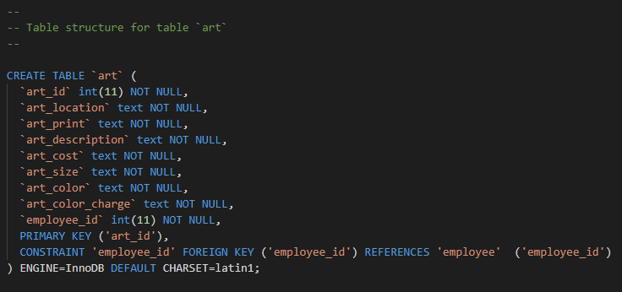

**Customer Table**

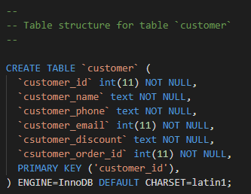

**Employee Table**

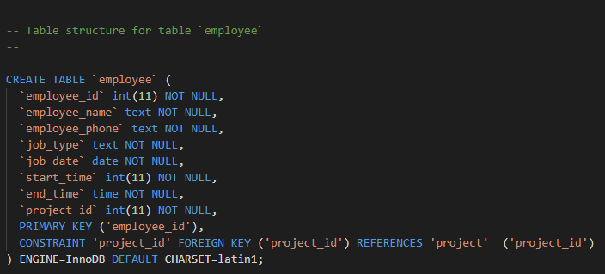

**Invoice Table**

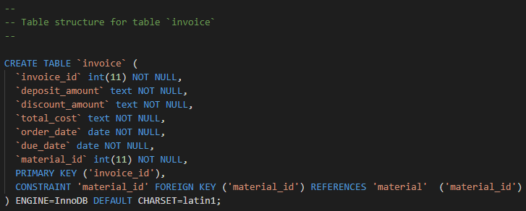

**Material Table**

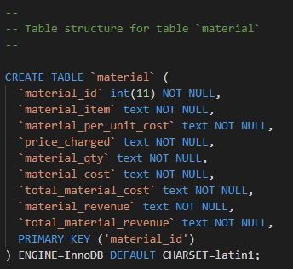

**Labor Table**

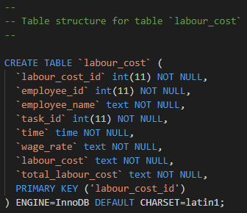

**Order Date Table**

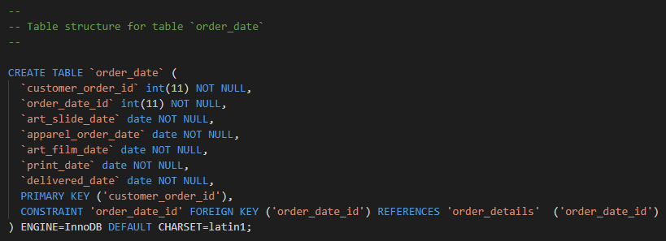

**Order Details Table**

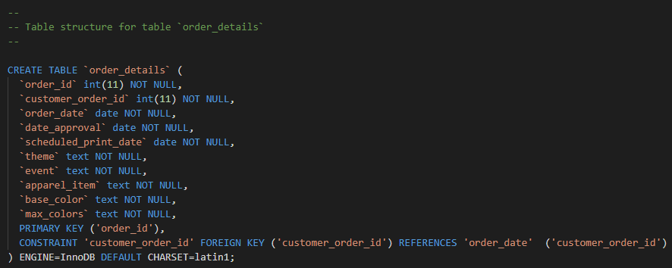

**Print Order Table**

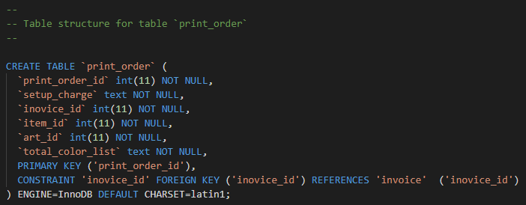

**Project Table**

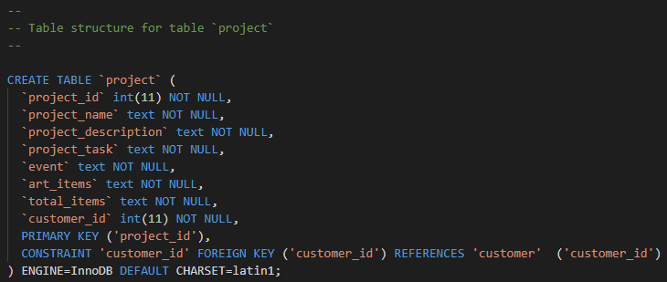

**Revenue Table**

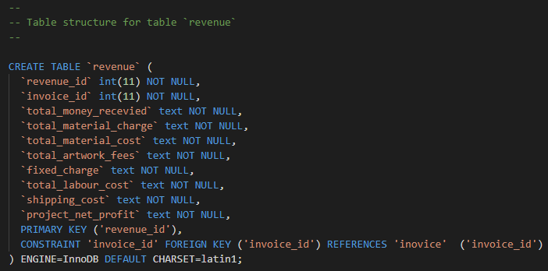

3.2 Software Stack

3.2.1 Database:

* MySQL

3.2.2 Programming Language:

* **Backend**: Core PHP
* **Frontend**: HTML, CSS, Bootstrap, JavaScript

3.2.3 Software:

* Xampp
* PhpMyAdmin
* Visual Studio Code Editor

**3.2.4 Hardware**:

* Operating System: Windows 11

# **4.0 Results and Discussion**

This chapter includes an objective description and analysis of the application results (outputs screens and reports). Limit the use of charts, tables, and figures to those that are needed to support the narrative. Full reports can be included as part of the appendices.

The following topics are intended to serve as a guide:

* Functional process screens.
* Fully explained query Reports.
* Summary of screen results or reports and explained in detail.

4.1 Screens

**Login Screen**

**Sign Up**

**Dashboard**

**Artwork Order**

**Add Artwork Order**

**Employee Work Log**

**Add Employee Work Log**

**Print Order**

**Add Print Order**

**Project Cost Analysis**

**Add Project Cost Analysis**

# **5.0 Conclusions**

5.1 Significance

* Practical design-based database and web application experience

5.2 Learnings from this project

* Performing CRUD operations
* Application of database concept to real world objects.
* Application of front-end development tools
* We understand the how we can normalize any big sets of databases, how we can make it redundant and improve its efficiency.
* Also, Got exposure and hands-on experience in Programming language like HTML, CSS, Bootstrap, PHP.

5.3 Future Work

* In Future using AI and Computer Vision on the system we can create 3D trial on the system itself.
* We can predefine some items into the database so that it will be easy to add in invoice.
* We can improve User Interaction with the system.
* we can build a dynamic data set which can contain the values of different variants of same products.
* We can make an analysis system with the help of data base that what kind of customers are coming to BOB. (What are their preferences, likes, dislikes, size, etc...)

# **6.0 Appendices**

**Includes/**

breadcrumb.php

connections.php

footer.php

header.php

**map/**

style.css.map

**assests/**

**js/**

dashboard.js

main.js

map.js

**sass/**

accordion.scss

alerts.scss

badges.scss

btn.scss

cards.scss

datepicker.scss

dropDown.scss

features.scss

forms.scss

modal.scss

pagination.scss

pricing.scss

progressbar.scss

range-slider.scss

social.scss

components.scss

**element/**

breadcrumb.scss

content-block.scss

footer.scss

forum.scss

menu.scss

product.scss

sidebar.scss

tab.scss

team.scss

testimonial.scss

timeline.scss

elements.scss

**general/**

general.scss

**modules/**

dashboard.scss

product-single.scss

modules.scss

responsive.scss

style.scss

table-of-contents.scss

themes.scss

**vendor_assets/**

**css/**

**bootstrap/**

bootstrap.css

bootstrap.scss

config.bs.scss

animate.css

font-awesome.min.css

jquery-ui.css

line-awesome.min.css

magnific-popup.css

owl.carousel.css

select2.min.css

simple-line-icons.css

slick.css

trumbowyg.min.css

venobox.css

**fonts/**

fontawesome.otf

line-awesome.ttf

simple-line-icon.eot

**js/**

jquery-ui.min.js

owl.carousel.min.js

select2.full.min.js

slick.min.js

trumbowyg.min.js

venobox.min.js

waypoint.min.js

add-artwork-order.php

add-employee-work.php

add-print-order.php

add-project-cost-analysis.php

artwork-order.php

check.php

dashboard.php

delete.php

employee-details.php

index.php

login.php

logout.php

print-order.php

project-cost-analysis.php

signup.php

style.css

view-artwork-order.php

view-employee-work.php

view-order.php

view-print-order.php

view-project-cost-analysis.php